Ramadan during the Corona crisis
We wish everyone a nice and safe Ramadan
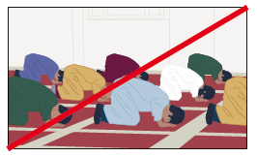
Do not pray together (groups prohibited)
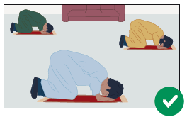
Pray with up to 3 people (keep 1.5 meters away)
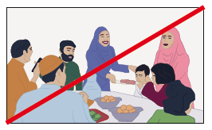
No big iftar; no big Sugar Feast

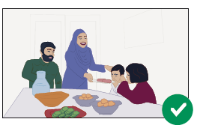
Dining only with your family.

Many mosques stream their prayer services over the internet. Inquire about this.

The following applies to everyone:
• keep at least 1.5 meters away, indoors and outdoors
• stay at home as much as possible
• avoid public transport
• groups prohibited, max. 3 persons
(possible fine: € 400)
